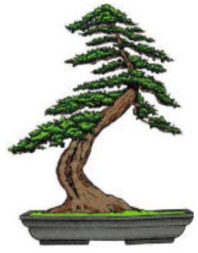 | Phoenix Bonsai Society  Valley Garden Center  1809 North 15th Avenue  Phoenix, Arizona 85007

PLEASE RETURN THIS FORM WITH YOUR PAYMENT

I would like to place an advertisement in the Phoenix Bonsai 20 xx – 20xx Handbook

½ Page advertisement $60.00 YES
Full Page advertisement $80.00 YES

I want the advertisement to be printed in your handbook in the same format you included in the mailing
(YES) _____ (NO) _____

Place the advertisement in your 20 xx – 20xx Handbook with the edits I have made on the advertisement you provided. I am returning these edits with my payment.

SIGNATURE / COMPANY NAME ____________________________________

