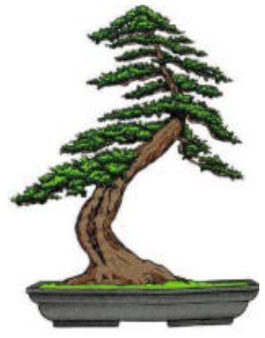 | Phoenix Bonsai Society  Valley Garden Center  1809 North 15th Avenue  Phoenix, Arizona 85007

Dear xxxxxxxxxxx:
The Phoenix Bonsai Society thanks you for your previous support of our club through your advertisement in our yearly handbook.

PBS would like to invite you to support the art of bonsai by advertising your business in our handbook for this coming season. Our handbook contains, among other things, advertisements for nurseries and those companies that sell items of interest for club members.

The cost for a full-page ad for less is $60.00
The cost for a full-page ad is $80.00

The cost of a published an advertisement also covers a full-size advertisement on our webpage found at www.Phoenixbonsai.com. Click on “Bonsai Supplies” to view the advertisements.

Since this website was set up in April 1999, some 106,769 unique visitors have come to the PBS webpage. It has gained national and international recognition. Over 100 visitors a week can view the nursery at supplier addresses on our website. Therefore, people from our local or anywhere in the world will able to view your advertisement.

I can’t express to you enough how much your valued support means to our club. We look forward to visiting you on the web, at conventions and on our annual club bus trip to California.

I have included a copy of your previous year’s advertisement along with a stamped self-addressed envelope for your convenience.

Make any needed revisions to the enclosed advertisement. Please send a check or money order to Phoenix Bonsai Society before August 1st.

Feel free to contact me at (xxx) xxx-xxxx or Email xxxxxxx@xxx.xxx should you have any questions.

Yours sincerely,

xxxxxx xxxxxxx,
Vice President Phoenix Bonsai Society

