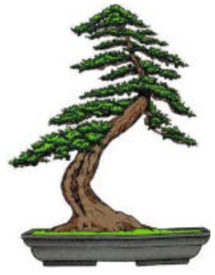 | Phoenix Bonsai Society  Valley Garden Center  1809 North 15th Avenue  Phoenix, Arizona 85007

Dear xxxxxxxxxxx:
The Phoenix Bonsai Society would like to invite you to support the art of bonsai by advertising your business in our handbook for this coming season.

Our handbook contains among other things advertisements for nurseries in those companies that sell items of interest for bonsai club members.

The Phoenix Bonsai Society (PBS) was established in Phoenix in 1962 and is one of the original founding members of the American Bonsai Society. Our mission is to promote the art of bonsai in the desert. Our club participates in several local events each year displaying our trees at the Japanese Matsuri festival and various other events throughout the year.

The cost for a full-page ad for less is $60.00
The cost for a full-page ad is $80.00

The cost of a published an advertisement also covers a full-size advertisement on our webpage found at www.Phoenixbonsai.com. Click on “Bonsai Supplies” to view the advertisements.

Since this website was set up in April 1999, some 106,769 unique visitors have come to the PBS webpage. It has gained national and international recognition. Over 100 visitors a week can view the nursery at supplier addresses on our website. Therefore, people from our local or anywhere in the world will able to view your advertisement.

I have included a sample of how your advertisement might appear, along with a stamped self-addressed envelope for your convenience.

We look forward to visiting you on the web and at conventions.

Please send a check or money order to Phoenix Bonsai Society before August 1st and include your advertisement and web information or any revisions to existing for the enclosed advertisement.

Feel free to contact me at (xxx) xxx-xxxx or Email xxxxxxx@xxx.xxx should you have any questions.

Yours sincerely,

xxxxxx xxxxxxx,
Vice President Phoenix Bonsai Society

